WRITING CLASSES ( CHAPTER 4)

Three fundemental concepts of object-oriented programming :
- encapsulation
- inheritance
- polymorphism

students

attributes operations(methods)
name getStudentName
major getStudentAddress
address setMajor
DOB setLastName
GPA

Members of a class

Variables Methods


Die class:How to use, how to construct the class

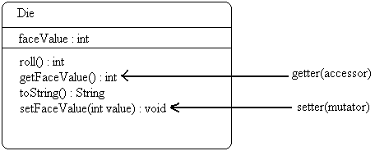

public class RollingDice
//creates two dice objects and rolls them several times
public static void main (String[] args)
{
Die die1,die2;
int sum;

die1 = new Die();
die2 = new Die();

die1.roll();
die2.roll();
System.out.println(“Die one: “ + die1 + “ Die two: “ + die2);

//Output:
//Die one : 5 Die two : 2

die1.roll();
die2.setFaceValue(4);
System.out.println(“Die one: “ + die1 + “ Die two: “ + die2);

//Output:
//Die one : 1 Die two : 4

Sum = die1.getFaceValue() + die2.getFaceValue();
System..out.println( “Sum: “ + sum);
//Output:
//Sum:5
}
}

public class Die
{
private final int MAX = 6;
private int faceValue;

//constructor
public Die()
{
faceValue = 1;
}

public Die (int initialFaceValue)
{
faceValue = initialFaceValue;
}

//-------------------------------------------
//roll the die and return the result
//-------------------------------------------

public int Roll( )
{
faceValue = (int) (Math.random( ) * MAX) +1;
return ( faceValue );
}

//face value accessor
public int getFaceValue( )
{
return faceValue;
}

//face value mutator
public void setFaceValue( int value )
{
faceValue = value;
}

public void setFaceValue (int value)
{
if (value <= 6 && value >0)
faceValue = value;
else
faceValue =6;
}

public String toString()//it converts an integer to a String
{
String result = Integer.toString(feeValue);
return result;
}

public class Die
{
private final int MAX = 6;
private int faceValue;

//...................................
//constructor
//...................................

public Die()
{
faceValue = 1;
}

//....................................
public Die (int k)
{
faceValue = k;
}

public Die ( Die otherDie)
{
faceValue = otherDie.faceValue;
}

public String toString()
{
String result = Integer.toString(faceValue);
return result;
}

System.out.println( " die 1: " + die1 + "die2: " +die2);

Assume that we have no toString()

die1 = @ 14E4FA
die2 = @ EE44BA

int = 10;
System.out.println(" i : " +i);

Assume that we have to toString() method
die1 = 1
die2 = 4

public int rollDie()
{
faceValue = (int)(Math.random()*MAX) + 1;
return faceValue;
}

Die die1 = new Die();
System.out.println("die1: "+die1);
die1 =1

die1.rollDie();
System.out.println("die1: "+die1);
die1 =5

public int getFaceValue()
{
return faceValue;
}

private String convertToString()
{
String r;
r = Integer.toString(faceValue);
return r;
}

System.out.println(die1.convertToString());

//reimplement toString()

public String toString ()
{
String result;
result = convertToString();
return result;
}

System.out.println("die1 : " + die1);
}

Bank Account Example

import java.text.NumberFormat;
public class Acount
{
private final double RATE = 0.035;
private long acctNumber;
private double balance;
private String name;

//constructor (there is no return type for the constructor)
public Account ( String owner, long account, double initial);
//formal parameters(arguments)
{
name = owner;
acctNumber = account;
balance = initial;
}

public double deposit (double amount)
{
balance = balance + amount,
return balance;
}

public double withdraw (double amount, double fee)
{
balance = balance- amount-fee;
return balance;
}

public double addInterest()
{
balance = balance + (balance*RATE);
return balance;
}

public double getBalance()
{
return balance;
}

public String toString()
{
NumberFormat fmt = NumberFormat.getCurrencyInstance();
return ( acctNumber + "/t" + name+ fmt.format(balance));
}

}

MAIN:
{ Account acct1 = new Account ("'ali', 7526, 150.50);
acct1.deposit(10.50);
//actual parameter
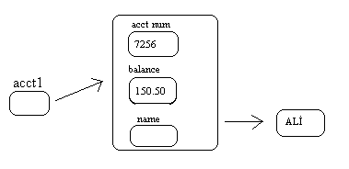
Account acct2 = new Account (‘veli’, 8888, 100.75);
acct2.deposit(10.0);

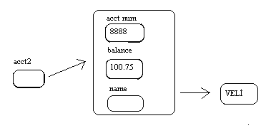

acct1.withdraw(5.0,1.0);
acct2.withdraw(1.0);
System.out.println("account2: "+acct2);
//Output: account2 8888 Veli $ 104.75

Graphical Objects

import java.awt.*;
public class Circle
{
private int diameter,x,y;
private Color circleColor;
public Circle (int size,Color shade, int upperX, int upperY);
{
diameter = size;
circleColor = shade;
x = upperX;
y = upperY;

}

public void draw (Graphics page)
{
page.setColor(circleColor);
page.fillOval(x,y,diameter,diameter);
}
}

import java.swing.*;
import java.awt.*;

public class SplatPanel extends JPanel
{
private Circle circle1, circle2, circle3, circle4, circle5;
public SplatPanel()
{
circle1 = new Circle(30,Color.red,70,35);
circle1 = new Circle(50,Color..green,30,20);
circle1 = new Circle(100,Color..cyan,60,85);
circle4 = new ....
circle5 = new ....

this.setPrefferedSize (new Dimension(300,200));
this.setBackground(Color.black);
}

public void PaintComponent(Graphics page)
{
super.paintComponent(page);
circle1.draw(page);
circle2.draw(page);
circle3.draw(page);
circle4.draw(page);
circle5.draw(page);
}
}

//****************

import javax.swing.*;
import java.awt.*;

public class Splat

{
//create and display the BMI GUI

public static void main ( String [] args)
{
JFrame frame = new JFrame ("splat");
frame.setDefaultCloseOperation(JFrame.EXIT_ON_CLOSE);

splatPanel panel = new splatPanel();
frame.getContentPane().add(panel);
frame.pack();

frame.setVisible(true);
}
}

QUESTIONS

- Design and implement a class called PlayerValue contains instance data that represents the player’s name, age, and value. Write a method that increases the player’s value %1 for aech goal he scores and a method that increases the value %0,5 for each assist he makes. Include toString method that returns a one line description of player’s information, Create a driver class called PlayerInformation whose main method instantiates and updates several PlayerValue objects.

Answer1:
//driver class

public class PlayerInformation
{

public static void main(String[] args)
{
PlayerValue p1=new PlayerValue("Kaan Dolunay",20,6000000);
PlayerValue p2=new PlayerValue("Leo Messi",19,3000000);
PlayerValue p3=new PlayerValue("Arjen Robben",21,2000000);

p1.goal(25);
p2.goal(13);
p3.goal(8);

p1.asist(16);
p2.asist(12);
p3.asist(15);

System.out.println();
System.out.println(p1);
System.out.println();
System.out.println(p2);
System.out.println();
System.out.println(p3);
System.out.println();
}
}

//class

public class PlayerValue
{

private String name;
private int agep;
private double fee;
private final double goalPers=0.01,asistPers=0.005;

public PlayerValue(String player,int age,double value)
{
name=player;
agep=age;
fee=value;
}

public double goal(int score)
{
fee=fee+(fee*score*goalPers);
return fee;
}

public double asist(int pas)
{
fee=fee+(fee*pas*asistPers);
return fee;
}

public String toString()
{
return (name+"\t"+agep+" years old\t"+fee+"$");

}

}

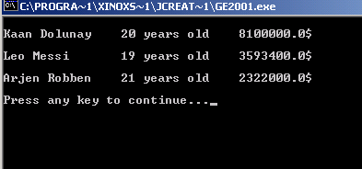

- Develop an application that implements a user interface for converting euro value to YTL value. And uses a convert button to calculate the result.

Answer2:

import javax.swing.JFrame;
/**
* AWT Sample application
*
* @author
* @version 1.00 04/08/31
*/
public class CurrencyConverter
{

public static void main(String[] args)
{

JFrame frame=new JFrame("CurrencyConverter");

CurrencyPanel panel=new CurrencyPanel();

frame.getContentPane().add(panel);
frame.pack();
frame.setVisible(true);

}
}

import java.awt.*;
import javax.swing.*;
import java.awt.event.*;

public class CurrencyPanel extends JPanel
{
private JLabel label,label2,label3;
private JTextField euro;
private JButton convert;
public CurrencyPanel()

{
convert=new JButton("convert");
convert.addActionListener(new CurrencyListener());

label=new JLabel("Enter the Euro value: ");
label2=new JLabel("Value in YTL: ");
label3=new JLabel(" ");

euro = new JTextField(5);
euro.addActionListener(new CurrencyListener());
add (convert);
add (label);
add (euro);
add (label2);
add (label3);

setPreferredSize(new Dimension(200,100));
setBackground(Color.cyan);

}

private class CurrencyListener implements ActionListener

{
public void actionPerformed(ActionEvent event)

{
double tl;
int eu;

String text=euro.getText();

eu=Integer.parseInt(text);
tl=eu*1.875;

label3.setText(Double.toString(tl));

}

}
}

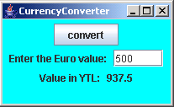

- Develop an application that implements user interface to change the value of the number which user enters. Use 3 buttons to increase the number one by one, to decrease the number one by one, and to take the square of the number.
Answer3:

import java.awt.*;
import javax.swing.*;
import java.awt.event.*;

public class CurrencyPanel extends JPanel
{
private JLabel label,label2,label3;
private JTextField euro;
private JButton convert;
public CurrencyPanel()

{
convert=new JButton("convert");
convert.addActionListener(new CurrencyListener());

label=new JLabel("Enter the Euro value: ");
label2=new JLabel("Value in YTL: ");
label3=new JLabel(" ");

euro = new JTextField(5);
euro.addActionListener(new CurrencyListener());
add (convert);
add (label);
add (euro);
add (label2);
add (label3);

setPreferredSize(new Dimension(200,100));
setBackground(Color.cyan);

}

private class CurrencyListener implements ActionListener

{
public void actionPerformed(ActionEvent event)

{
double tl;
int eu;

String text=euro.getText();

eu=Integer.parseInt(text);
tl=eu*1.875;

label3.setText(Double.toString(tl));

}

}
}

import java.awt.*;
import java.awt.event.*;
import javax.swing.*;

public class NumPanel extends JPanel

{
private JButton increase,decrease,square;
private JLabel label;
private int count;
private JTextField num;

public NumPanel()

{

num=new JTextField(5);
num.addActionListener(new ButtonListener());

increase=new JButton("Increase");
increase.addActionListener(new ButtonListener());

decrease=new JButton("Decrease");
decrease.addActionListener(new Button1Listener());

square=new JButton("Square");
square.addActionListener(new Button2Listener());

label=new JLabel(""+count);

add (num);
add (increase);
add (decrease);
add (square);
add (label);

setPreferredSize(new Dimension(300,150));
setBackground(Color.yellow);

}

private class ButtonListener implements ActionListener

{

public void actionPerformed (ActionEvent event)
{

String text=num.getText();

count=Integer.parseInt(text);

count++;
label.setText(Integer.toString(count));

}

}

private class Button1Listener implements ActionListener

{

public void actionPerformed (ActionEvent event)
{

String text=num.getText();

count=Integer.parseInt(text);
count--;

label.setText(Integer.toString(count));
}

}

private class Button2Listener implements ActionListener

{

public void actionPerformed (ActionEvent event)
{

String text=num.getText();

count=Integer.parseInt(text);
count=count*count;

label.setText(Integer.toString(count));
}

}

}

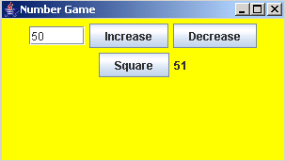

- Explain what component, event and listener means.

Answer4:

GUI component is an object that defines a screen element to display information or allow the user to interact with a program in a certain way/

An event is an object that represents some occurrence, in which we may be interested,

A listener is an object that “waits” for an event to occur and responds in some way when it does.

